**Experiment No :** 12

**Experiment name:** Write a C Program for factorial using recursion.

**Methodology :**

The factorial function is a recursive function that calculates the factorial of the input integer n. It checks if n is 0 or 1 and returns 1 (base case). Otherwise, it returns n multiplied by the factorial of n - 1. The program reads a non-negative integer from the user, calculates its factorial using the factorial function, and then prints the result. If a negative number is entered, it will display an appropriate error message

**Flow-Chart :**

Declear num

**Code :**

Factorial = factorial * num

Print factorial

scanf("%d" , &num);

Set Factorial = 1

Is num = 1 ?

N=num-1

#include<stdio.h>

long int recu_fact(int num);

long int recu_fact(int num){

if(num>=1){

return num * recu_fact(num-1);

}

else{

return 1;

}

}

int main()

{

int num ;

printf("Enter a Number : ");

scanf("%d" , &num);

printf("Factorial of %d = %d ", num , recu_fact(num));

return 0 ;

}

**Output:**

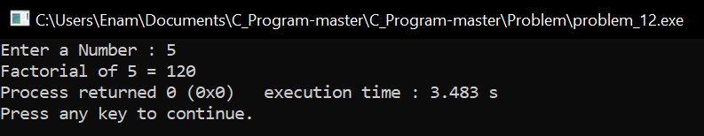

**Result discussion :**

Through this program we have seen how we can find the factorial number using the recursion function